# SilverSterling S3 Breakout w/ Drive Enable – QCI-BO-S3E(A)

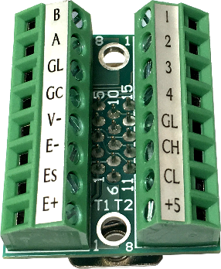 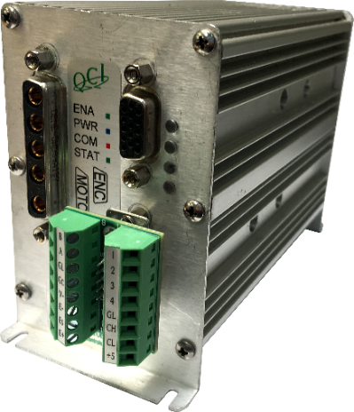

QCI-BO-S3E(A) – Top View

S3-IG with QCI-BO-S3E(A)

The QCI-BO-S3E and QCI-BO-S3EA basic breakouts connect directly to the SilverSterling S3’s 15-pin interface port (SIP) and break out, RS-485 communication, CAN, 4 I/O, and a hardware drive enable input. The hardware drive enable input allows the drive circuit to be hardware disabled, providing a hardware safety option that allows the entire driver circuit to be disabled while the control electronics remain active. Current position information as well as any other user information is maintained. The drive enable input requires 6V to 48V to enable the drive. See page 2 for drive enable wiring options.

The provided screws lock the breakouts to the DB15HD connector. There are two, 8 position terminal blocks that secure wiring. Terminal Connector Wire Range: 16-28 AWG

The QCI-BO-S3EAadds an active filter that translates the SilverSterling’sservo controller’s 0 to 3.3V PWM output on I/O #2 into a 0-5V analog output. Besides the special circuitry on I/O #2, the QCI-BO-S3EA is the same as the QCI-BO-S3E. Refer to the last page of this document for examples of how to use the QCI-BO-S3EA analog output feature.

## Pin-out Descriptions

|  |  |
| --- | --- |
| Pin # | Signal |
| 1 | E+ (Drive Enable +) |
| 2 | RS-485A |
| 3 | +5v Output (100mA) |
| 4 | I/O #3 |
| 5 | CAN High |
| 6 | E- (Drive Enable -) |
| 7 | Es (Drive Enable Source) |
| 8 | Logic Ground |
| 9 | I/O #2 |
| 10 | Logic Ground |
| 11 | Power Ground |
| 12 | RS-485B |
| 13 | I/O #1 |
| 14 | I/O #4 |
| 15 | CAN Low |

## 

QCI-BO-S3E

# Q:\Support\Info DB\Final\QCI-TD Technical Docs\QCI-TD089 QCI-BO-S3E S3 breakout with drive enable\support\QCI-BO-S3E.png

DB15HD Connector View

# How to Use

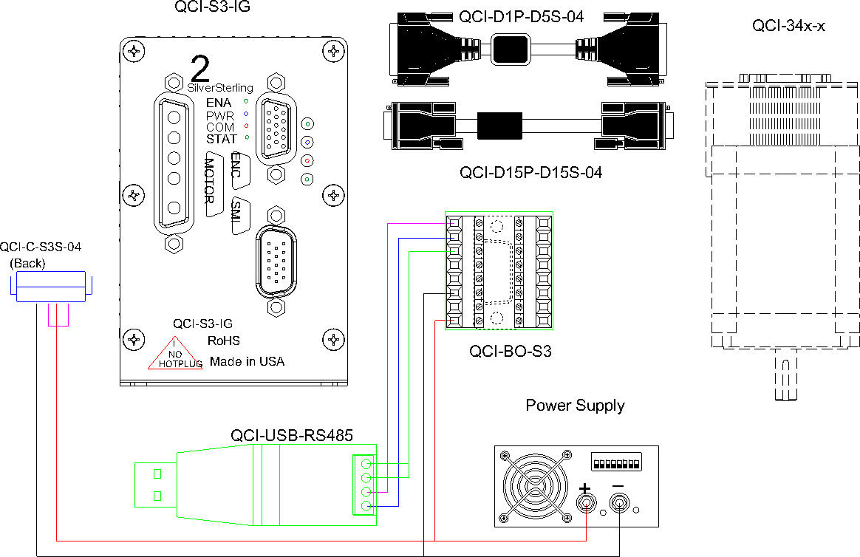

QCI-BO-S3E

# Drive Enable Wiring Options

1. 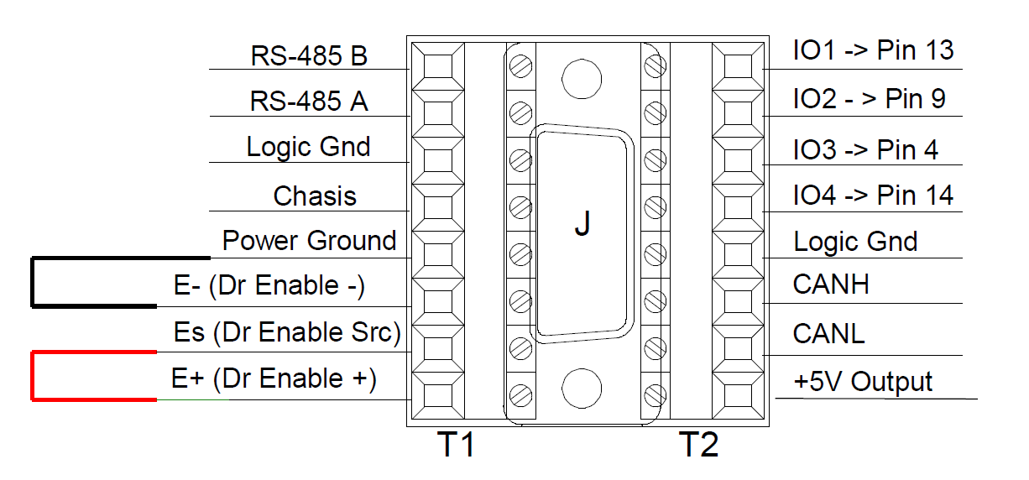**No drive enable functionality (Factory Default).**
   1. Two wire jumpers are applied across terminals
      1. E+ (Drive Enable+) **🡨🡪** Es (Dr Enable Src)
      2. E- (Drive Enable-) **🡨🡪** Power Ground
   2. Notes:
      * This option configures the drive enable to always be enabled.
      * Driver can still be disabled via software.
2. **Isolated drive enable input**

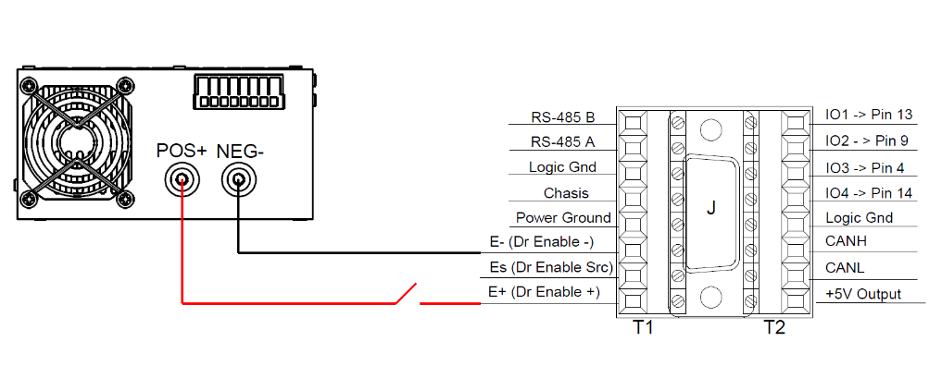

* 1. Connect E- (Drive Enable-) to negative power supply terminal.
  2. Connect E+ (Drive Enable+) to positive power Supply terminal (6V to 48V) in series with an E-stop switch.
  3. Notes:
     + For full isolation, use separate/isolated power supplies for drive enable input and S3 driver power (6-pin blue power connector).
     + If full isolation isn’t required, the same power supply can be used for both drivers enable input and S3 driver power.

# How to Use QCI-BO-S3EA

Configure the PWO command to get duty cycle from lower or upper word of any register. As this word ranges from -32768 to 32767, the PWM output (I/O #2) duty cycle ranges from 0 to 100% at 3.3V. The QCI-BO-X3A filters this PWM output and amplifies it to 0-5V.

Note: PWO “Mode” parameter may have the following values:

Disable, High Word, Low Word

Use the following equation to determine the Register Value (R) for the desired X3A output voltage (Vo):

R =



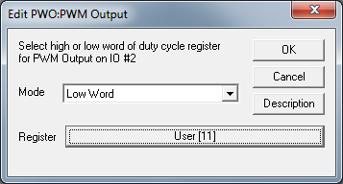**Example 1:**

Desired analog output is 1.75 volts.

1. Configure PWO to get duty cycle from lower word of User Register 11.
2. Set Register 11 according to the following equation:

R =



R =



R =



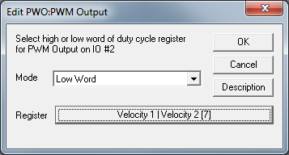**Example 2:**

Output Analog Actual Velocity

All SilverLode servo systems store velocity in Register 7 [Velocity 1|Velocity 2]. Velocity 1 is the actual velocity filtered once. Velocity 2 is the actual velocity filtered twice. The above example uses Velocity 2. Velocity 2 is a signed 16-bit number where -32768 is –4000 RPM and +32767 is +4000 RPM. At zero speed, the output voltage will be 2.5 volts.

**Example 3:**

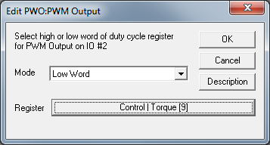Using Analog Output for Torque

All SilverLode servo systems store torque in Register 9 [Control | Torque]. The lower word is the actual output torque on the motor shaft. Torque values of –30000 is –150% torque and +30000 is +150% torque. The minus and plus represents clockwise and counter clockwise torque. A value of 0 is zero torque.